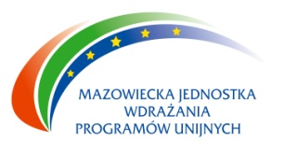 The Man – the best investment
Mazovian Unit for Implementation of EU Programmes in Warsaw announces the official launch of the call for proposals for innovative projects in the Human Capital Operational Programme 2007 – 2013, Priority VIII „Regional human resources”.
Projects should concern subject:
- „Analysis, testing and implementation of the idea of flexicurity”;
- „Methods of maintaining activity of workers in the age group 50 +”.
Applications will be accepted from 1st June to 30th June 2011.
The deadline for the submission of application is 30th June 2011 until 4 p. m.
Mazovian Unit for Implementation of EU Programmes allocates 12 000 000,00 PLN for this call for proposals. Minimum value of a project cannot be less than 1 000 000,00 PLN.
All institutions interested in the call are welcome to contact our contact point –
Points for receiving applications:
Mazovian Unit for Implementation of EU Programmes
ul. Jagiellońska 74, 03 -301 Warszawa
or Contact Points in Ciechanów, Ostrołęka, Płock, Radom, Siedlce,
and on website: www.mazovia.pl, www.mazowia.eu
We inform that there is a base of potential partners on the web-site –
http://www.kiw-pokl.org.pl


The announcement co-financed by the European Union under the European Social Fund

